**TESTING API USING POSTMAN AND CHECKING THE PORTAL**

**Authenticating User By Generating Token For Correct UserId and Password Combination:**

PostMan ScreenShot:

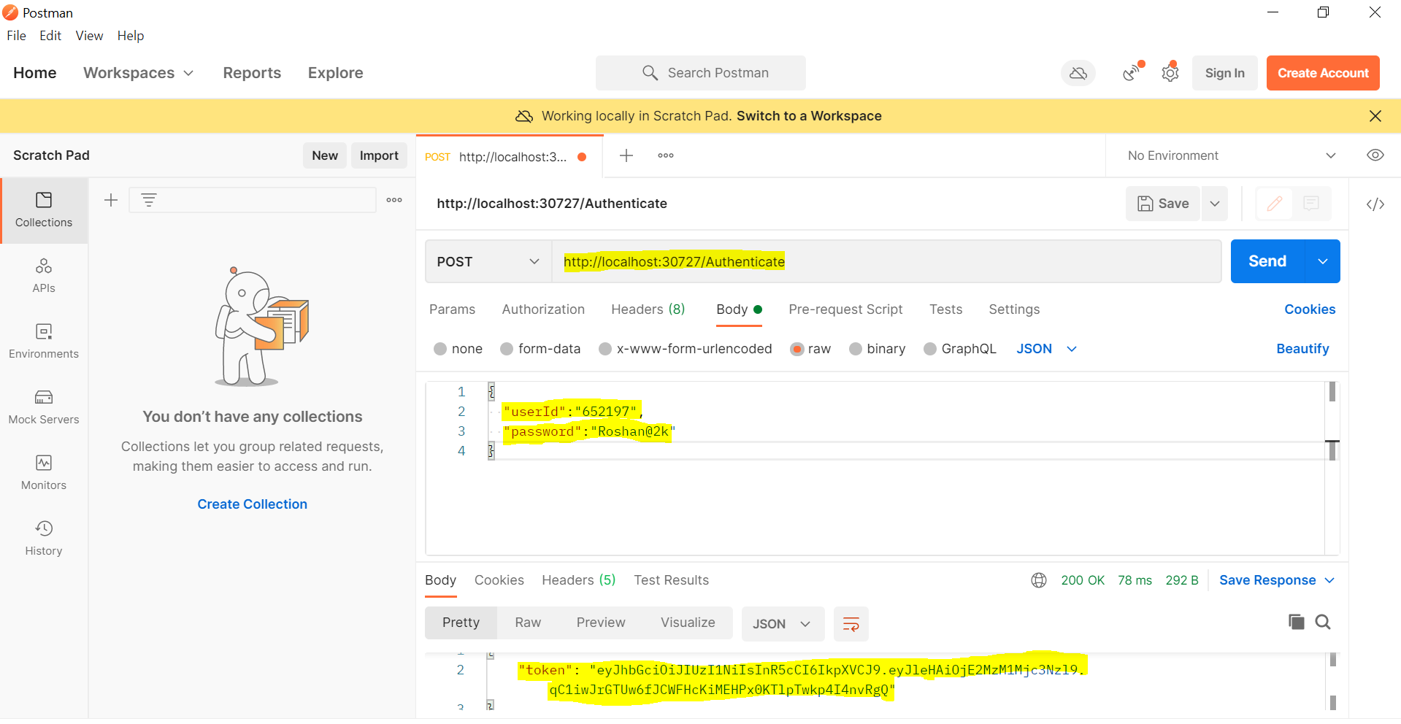

SQL Server ScreenShot:

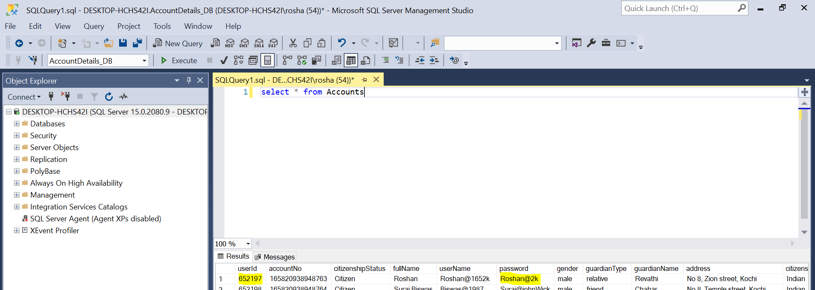

**New User Registration:**

PostMan ScreenShot:

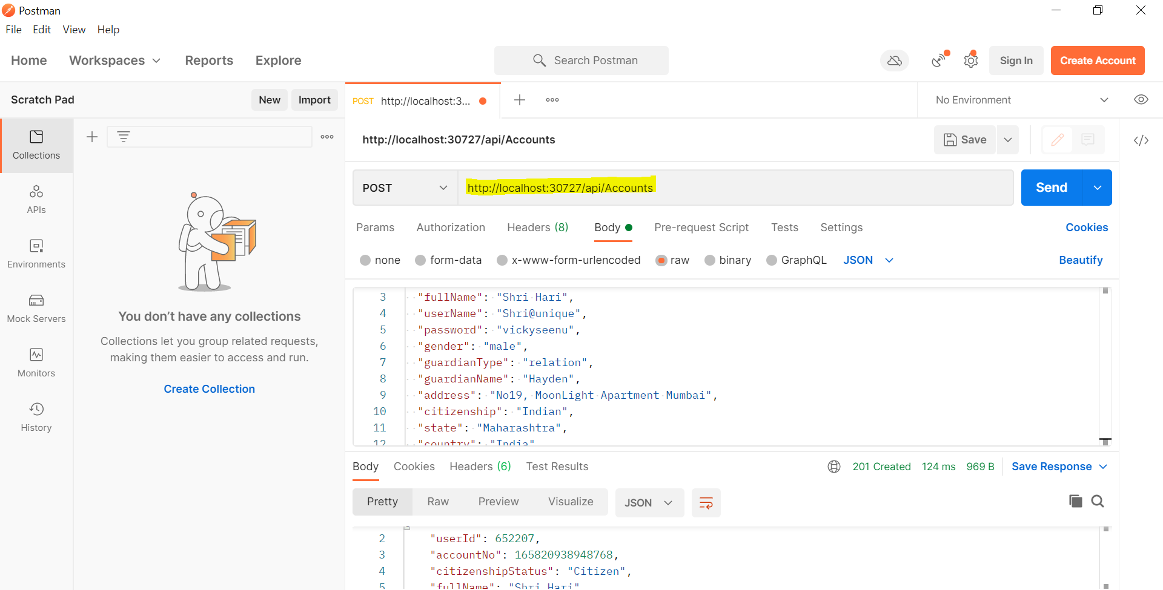

SQL Server ScreenShot:

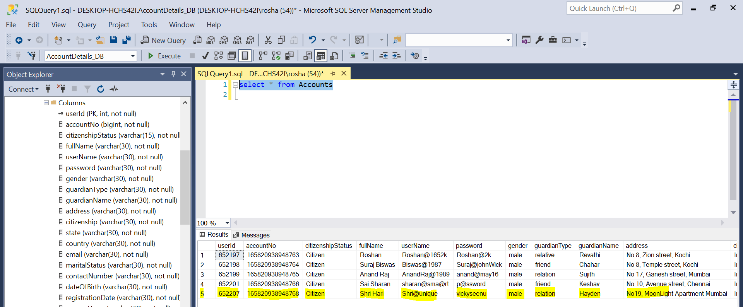

**Getting User Details By Id:**

Swagger ScreenShot:

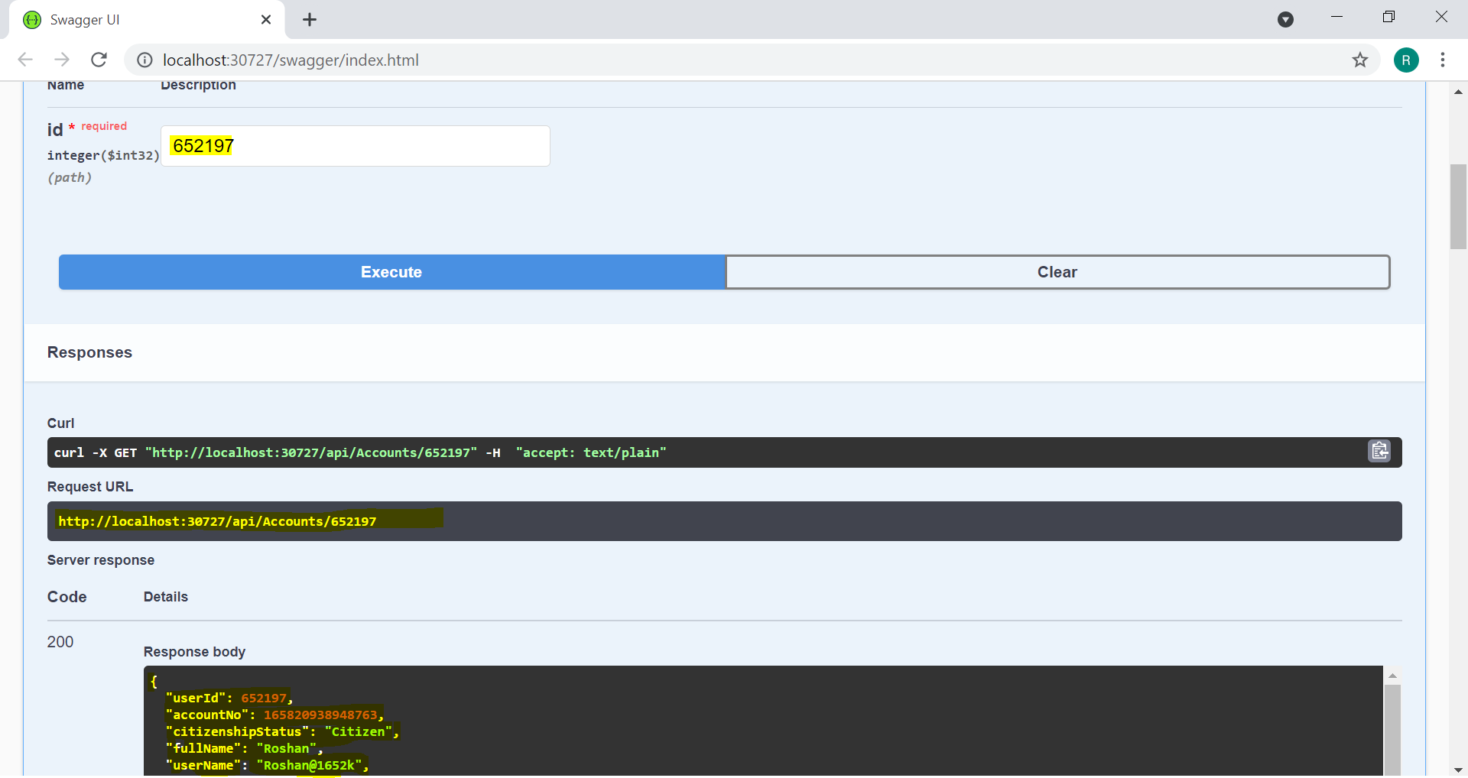

**Updating Data In Database using Put Method:**

Swagger ScreenShot:

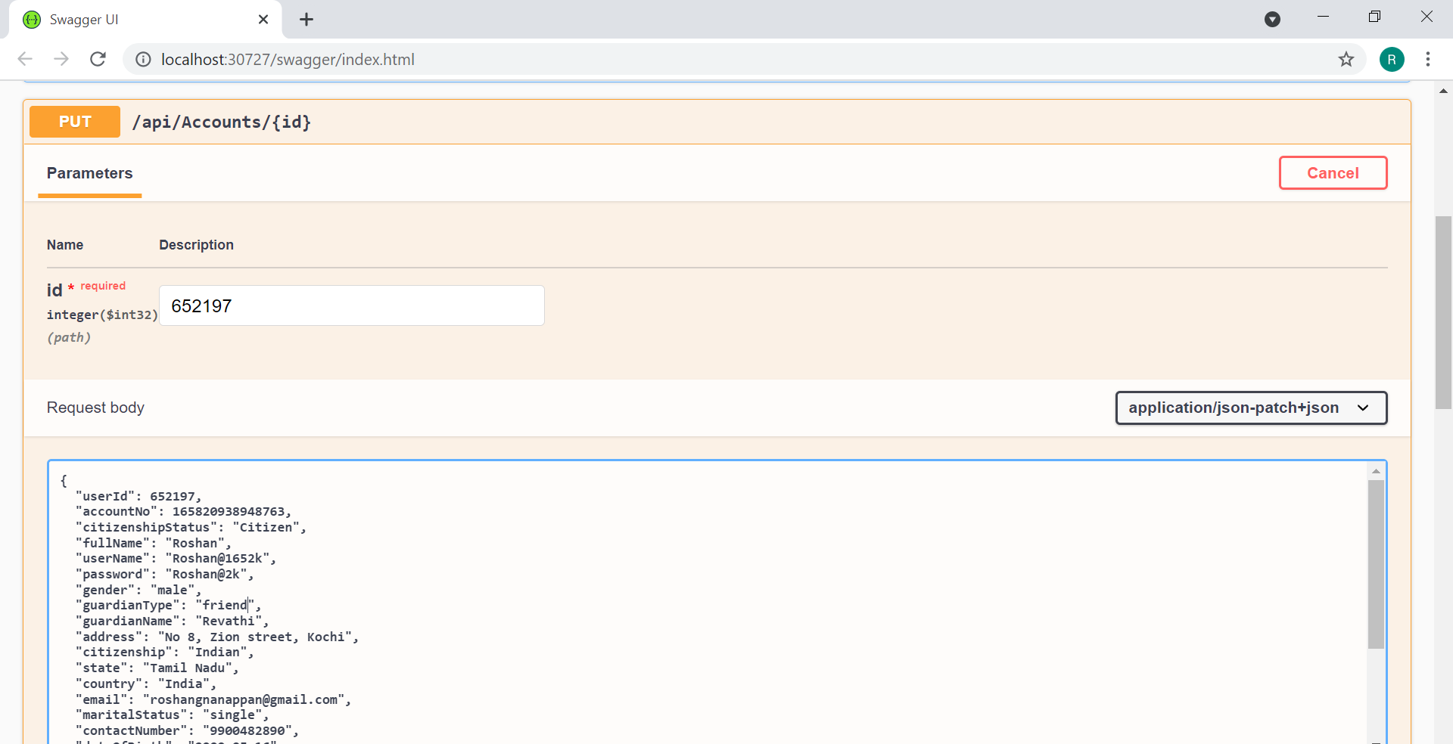

**Sending a Education Loan Application and Saving it in Database:**

PostMan ScreenShot:

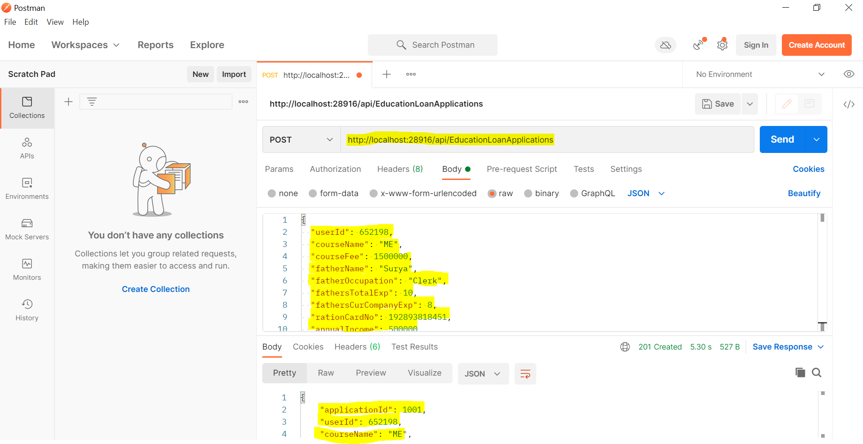

SQL Server ScreenShot:

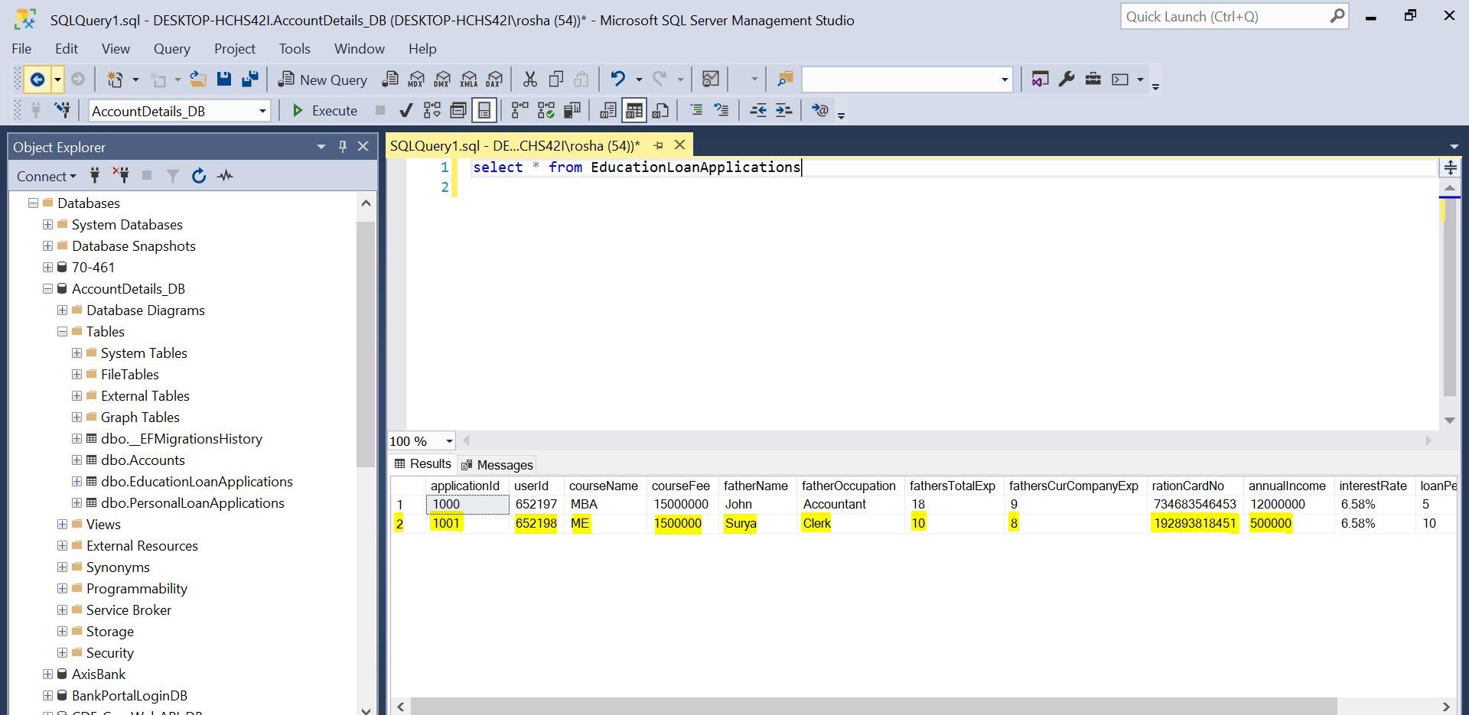

**Sending a Personal Loan Application and Saving it in Database:**

PostMan ScreenShot:

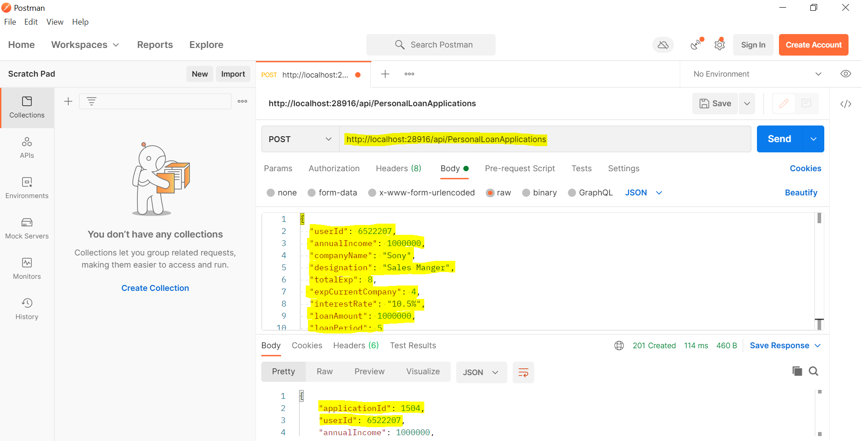

SQL Server ScreenShot:

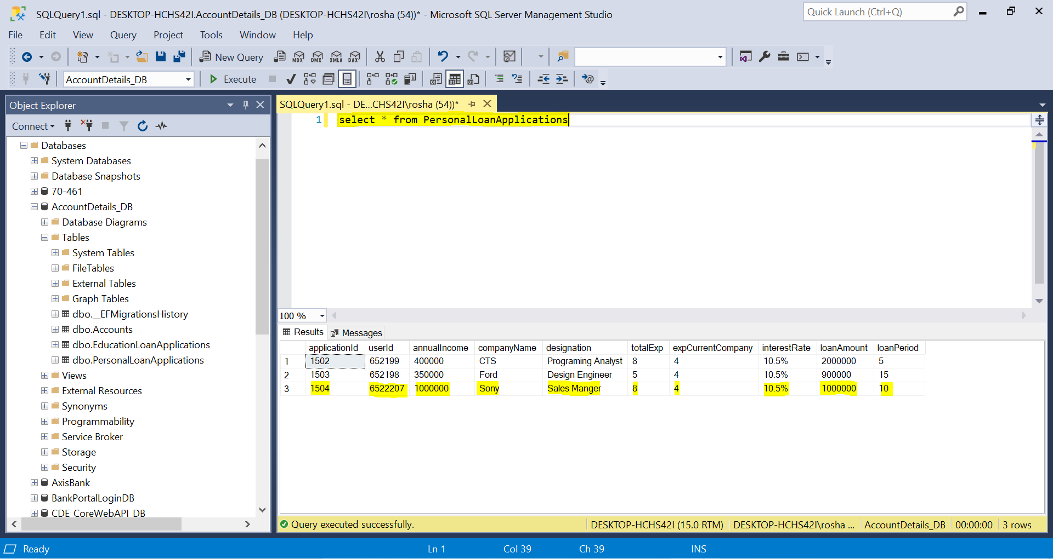

**Login Page:**

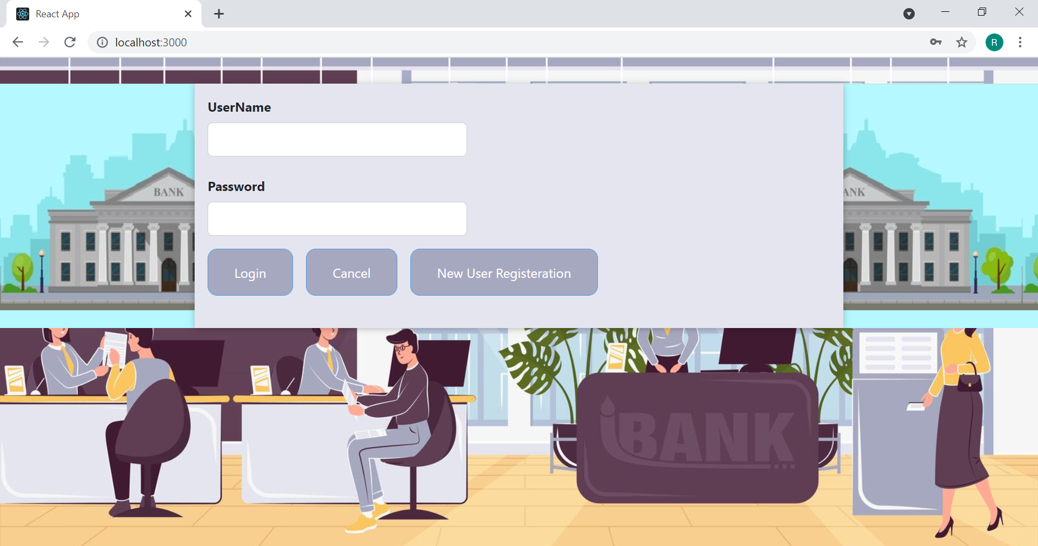

**If Given Credentials are Invalid:**

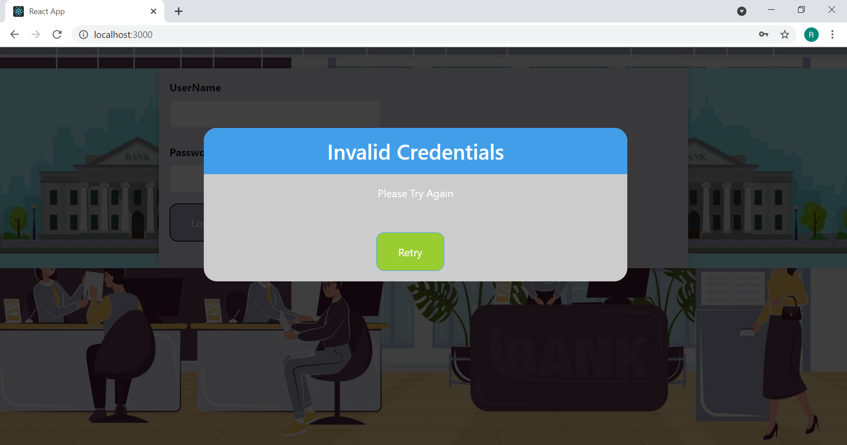

**New User Registration Page:**

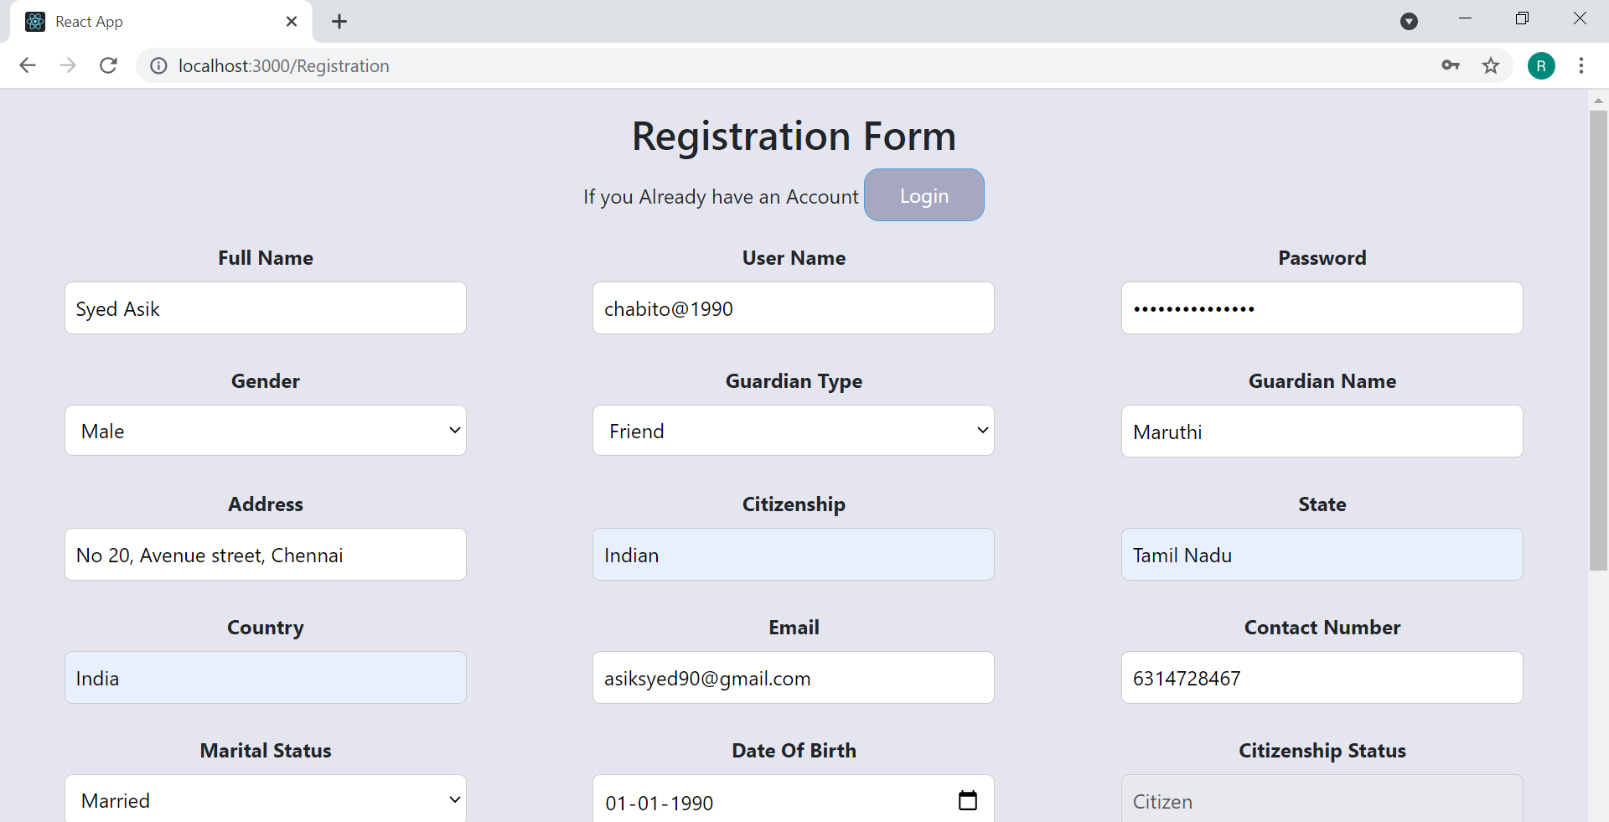

**After Successful Registration A Popup Will Appear With The Generated UserId & AccountNo:**

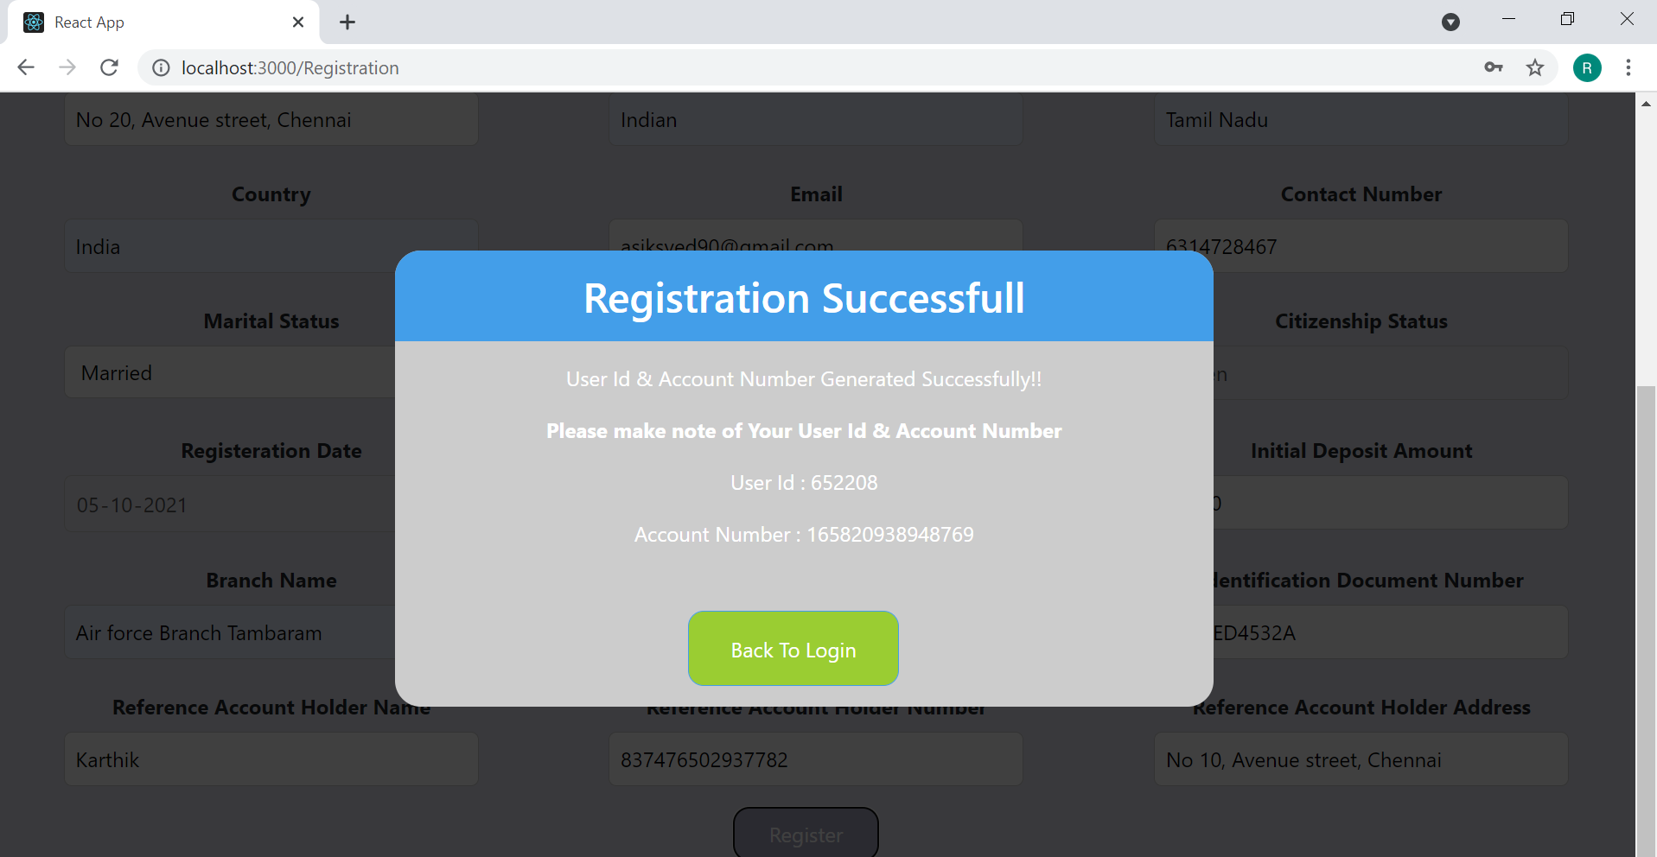

**If Correct UserId & Password are Entered At The Login Page You Will Be Redirected To The Home Page:**

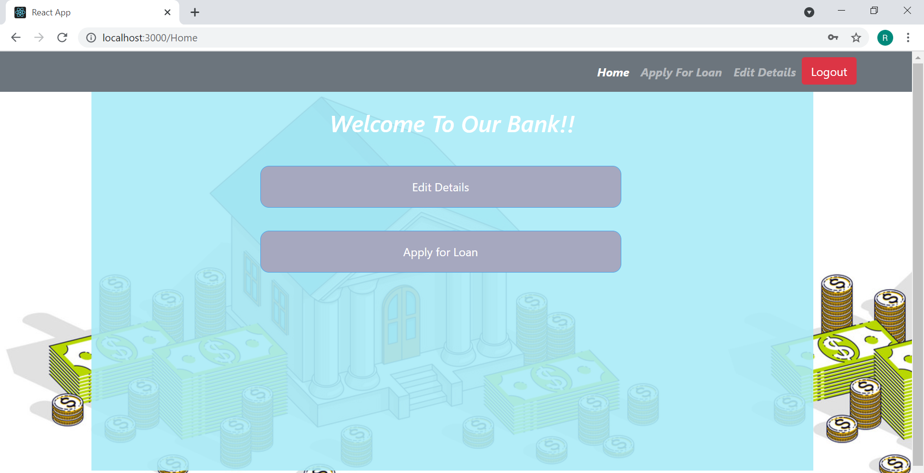

**Apply For Loan Page:**

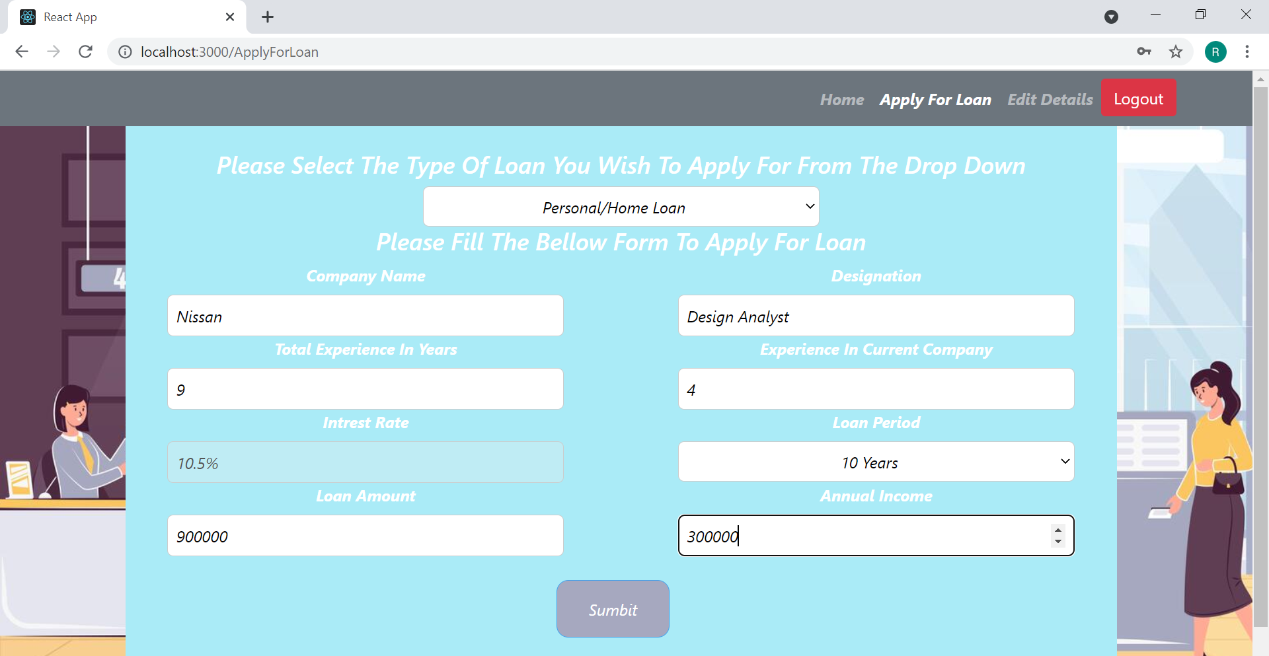

**After Entering Valid Data In the form for Apply for Loan you Will Receive a confirmation:**

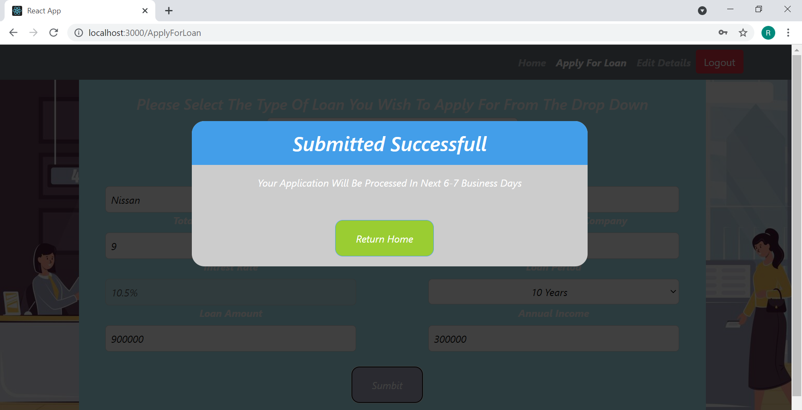

**Editing Details Page:**

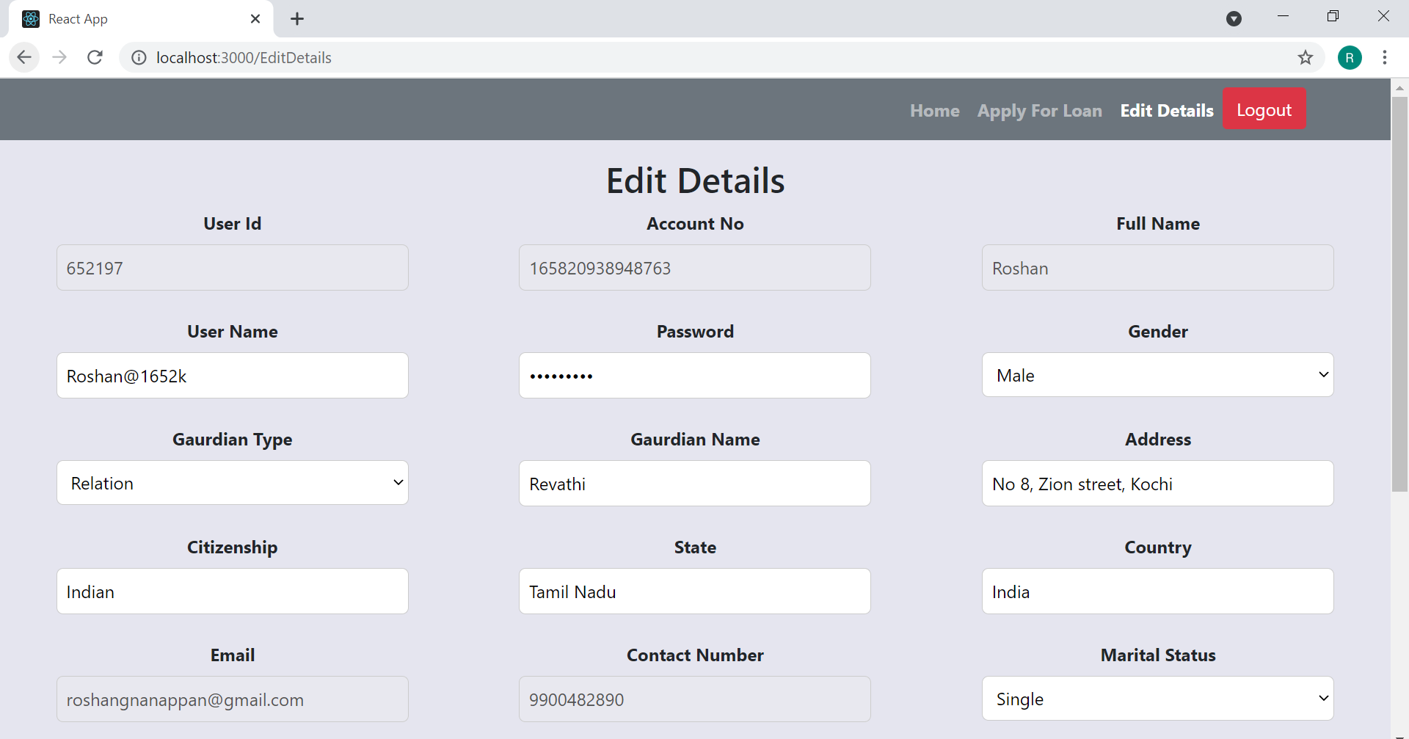

**After Changing The required data to be changed You will Receive a Confirmation:**

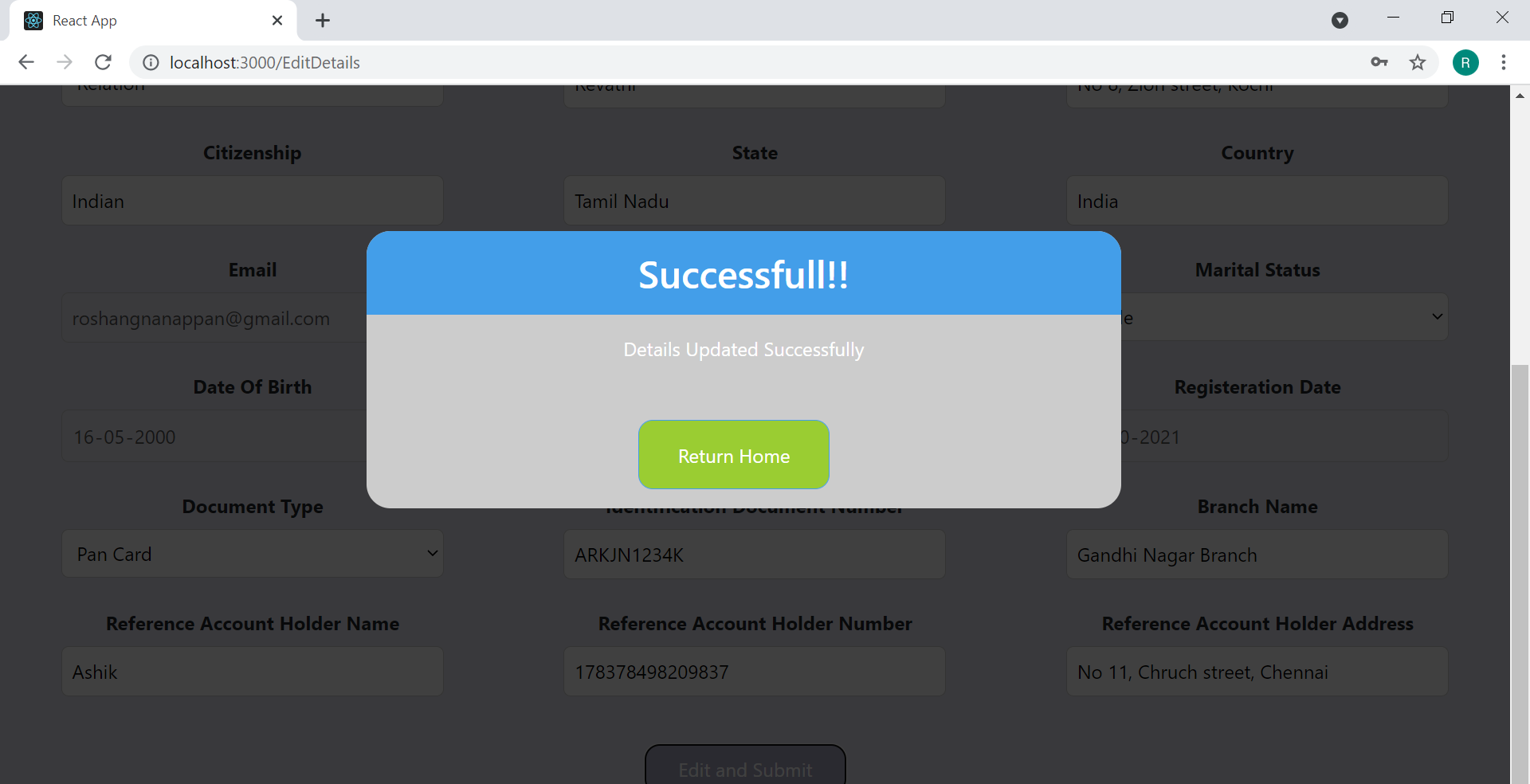

**If Any Error Occurs In The API Call Statement It Will Be Redirected To The Error Page:**

